TASK 22: Assignment Questions
Name of student: Shashwat N Wankhade
Domain/subject name:AI/ML
College and Branch name:Takshashila Polytechnic, Computer Engineering

Question 1: Data Loading & Preprocessing
Output:
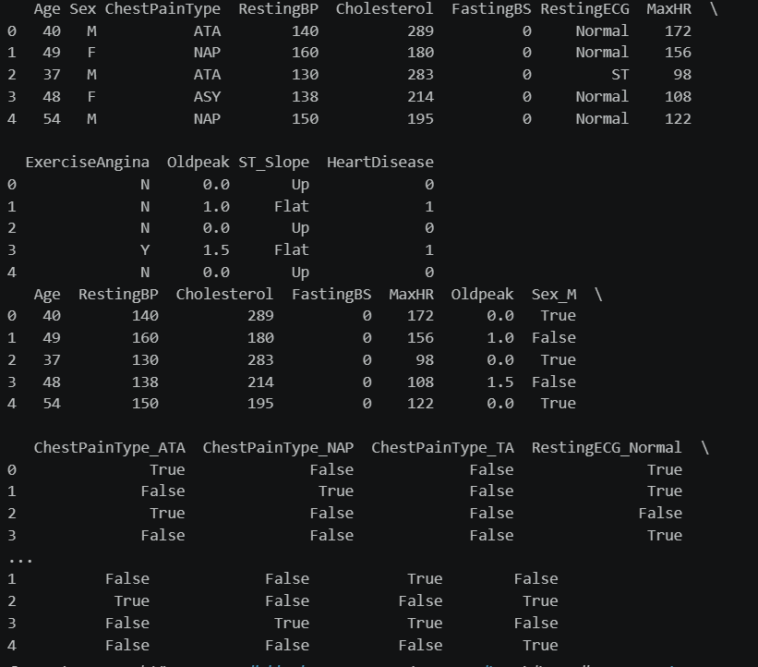
Code: import pandas as pd

# Load dataset
df = pd.read_csv("heart.csv.csv")

print(df.head())

# Separate features and target
X = df.drop("HeartDisease", axis=1)
y = df["HeartDisease"]

# One-Hot Encoding for categorical columns
X = pd.get_dummies(X, drop_first=True)

print(X.head())

Question 2: Train-Test Split
Output:
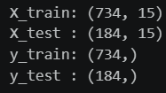
Code:
from sklearn.model_selection import train_test_split

X_train, X_test, y_train, y_test = train_test_split(
X, y,
test_size=0.20,
random_state=42
)

print("X_train:", X_train.shape)
print("X_test :", X_test.shape)
print("y_train:", y_train.shape)
print("y_test :", y_test.shape)

Question 3: Building Logistic Regression Model

Output:

Code:
from sklearn.linear_model import LogisticRegression

model = LogisticRegression(max_iter=1000)

model.fit(X_train, y_train)

print("Model trained successfully.")

Question 4: Making Predictions

Output:
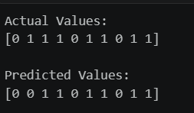

Code:
y_pred = model.predict(X_test)

print("Actual Values:")
print(y_test.head(10).values)

print("\nPredicted Values:")
print(y_pred[:10])

Question 5: Confusion Matrix
Output:
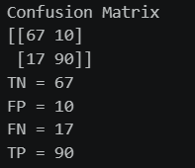
Code:
from sklearn.metrics import confusion_matrix

cm = confusion_matrix(y_test, y_pred)

print("Confusion Matrix")
print(cm)

TN, FP, FN, TP = cm.ravel()

print("TN =", TN)
print("FP =", FP)
print("FN =", FN)
print("TP =", TP)

Question 6: Model Evaluation Metrics
Output:
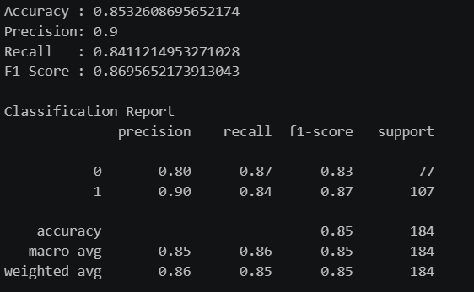
Code:
from sklearn.metrics import accuracy_score
from sklearn.metrics import precision_score
from sklearn.metrics import recall_score
from sklearn.metrics import f1_score
from sklearn.metrics import classification_report

print("Accuracy :", accuracy_score(y_test, y_pred))
print("Precision:", precision_score(y_test, y_pred))
print("Recall :", recall_score(y_test, y_pred))
print("F1 Score :", f1_score(y_test, y_pred))

print("\nClassification Report")
print(classification_report(y_test, y_pred))

Question 7: Saving the Model
Code:
import joblib

joblib.dump(model, "heart_model.pkl")

# No scaler used
joblib.dump(None, "scaler.pkl")

# Save column names
joblib.dump(X.columns.tolist(), "columns.pkl")

print("Model saved successfully.")

Question 8: Loading & Testing Saved Model
Output:
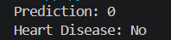
Code:-
import pandas as pd
import joblib

model = joblib.load("heart_model.pkl")
columns = joblib.load("columns.pkl")

sample = {
"Age": 45,
"Sex": "M",
"ChestPainType": "ATA",
"RestingBP": 120,
"Cholesterol": 230,
"FastingBS": 0,
"RestingECG": "Normal",
"MaxHR": 150,
"ExerciseAngina": "N",
"Oldpeak": 1.0,
"ST_Slope": "Up"
}

sample_df = pd.DataFrame([sample])

sample_df = pd.get_dummies(sample_df)

sample_df = sample_df.reindex(columns=columns, fill_value=0)

prediction = model.predict(sample_df)

print("Prediction:", prediction[0])

if prediction[0] == 1:
print("Heart Disease: Yes")
else:
print("Heart Disease: No")

Questions 9,10: Streamlit Input Interface, Complete Streamlit Web App
Output:
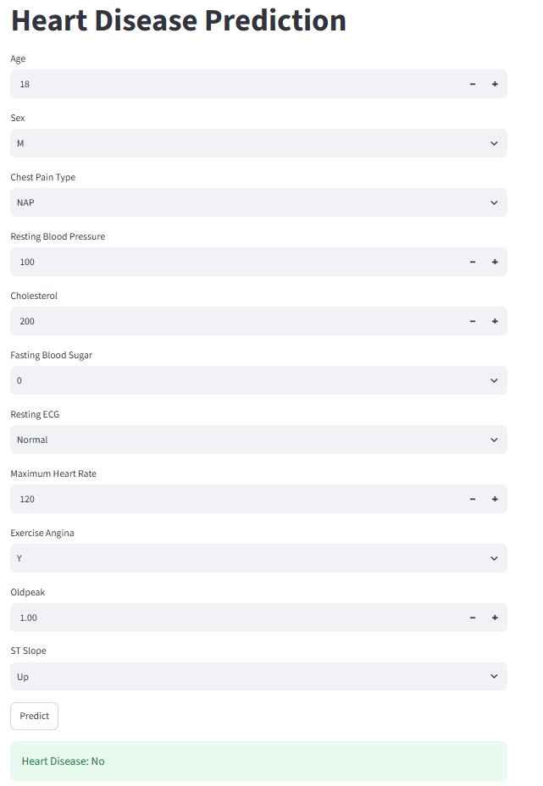
Code:
import streamlit as st
import pandas as pd
import joblib

model = joblib.load("Assignment_NO22/heart_model.pkl")
columns = joblib.load("Assignment_NO22/columns.pkl")

st.title("Heart Disease Prediction")

age = st.number_input("Age", 1, 120, 45)
sex = st.selectbox("Sex", ["M", "F"])
cp = st.selectbox("Chest Pain Type", ["ATA", "NAP", "ASY", "TA"])
bp = st.number_input("Resting Blood Pressure", 80, 250, 120)
chol = st.number_input("Cholesterol", 0, 700, 200)
fbs = st.selectbox("Fasting Blood Sugar", [0, 1])
ecg = st.selectbox("Resting ECG", ["Normal", "ST", "LVH"])
maxhr = st.number_input("Maximum Heart Rate", 60, 220, 150)
angina = st.selectbox("Exercise Angina", ["Y", "N"])
oldpeak = st.number_input("Oldpeak", 0.0, 10.0, 1.0)
slope = st.selectbox("ST Slope", ["Up", "Flat", "Down"])

if st.button("Predict"):

sample = pd.DataFrame([{
"Age": age,
"Sex": sex,
"ChestPainType": cp,
"RestingBP": bp,
"Cholesterol": chol,
"FastingBS": fbs,
"RestingECG": ecg,
"MaxHR": maxhr,
"ExerciseAngina": angina,
"Oldpeak": oldpeak,
"ST_Slope": slope
}])

sample = pd.get_dummies(sample)
sample = sample.reindex(columns=columns, fill_value=0)

prediction = model.predict(sample)[0]

if prediction == 1:
st.error("Heart Disease: Yes")
else:
st.success("Heart Disease: No")

